# Short-term objective:

1. Getting ready for the Thursday’s Hackathon in a very short time frame
2. Getting everyone involved in the project and clarifying everyone’s roles and responsibilities
3. To sustain high-performance teamwork

# Work flow:

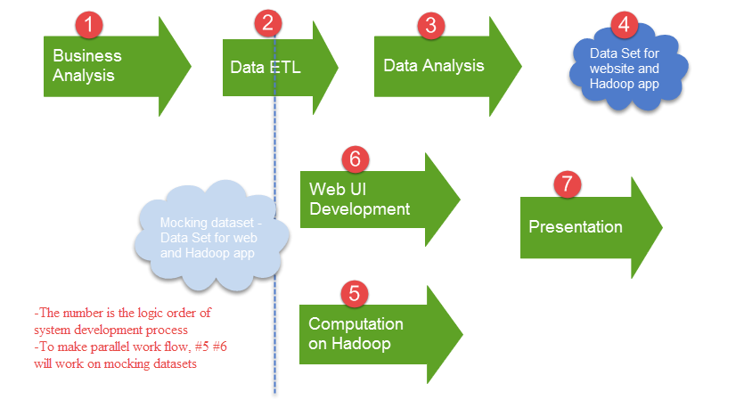

# Roles and Responsibilities

1. Business Analysis (Team)
2. Data ETL (Data acquisition)

Lisa, Kevin – Data resource level

Lily - Table level

Jake, Liusong – Column level

1. Data Analysis (Model building)

Monty, Lisa, Kevin

Based on the business analysis, to ask for data from Data ETL team.

Develop a “model” and generate dataset with scores

1. Web UI Development (Web-Repost development)

Jake, Kevin (The development will use various technologies, like system design and APIs, Liusong and lily will help)

User search page

Database/data file connection

New data insert page

Publish visualization map page – Jake (developer) should meet Kevin’s (client) requirements. Kevin helps test result and gives feedback

1. Computation on Hadoop (combine with #2)

Liusong, Lily, Lisa

To show how does spark application work on Hadoop cluster -> video

Platforms, concepts, technologies introduction - > PPT

Code locally to implement data algorithm and generate datasets

1. Presentation

Content:

1. Team and roles introduction
2. Business problem -> Solution -> $ save
3. IT architecture -> new technology is used -> performance compare with old one -> $ save